2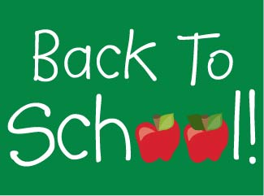

Supply List for Virginia J. Browning Primary School

(*Please do not label materials* with your child’s name)

3 pocket folders

1 pair of scissors

1 pencil case/bag

1 pack of markers

1 2 inch three ring binder (*2 of these for students 8 years and older*)

3 rolls of paper towels

3-4 large boxes of tissues

1 extra set of seasonally appropriate clothes to keep at school

1 water bottle to go from home to school

Other items:

* A sweater or long sleeved shirt to keep at school (the AC can get chilly)
* Extra batteries for device (s) to keep at school

**Gym/tennis shoes and socks are required for PE class each day. NO sandals or flip flops.**

**For safety reasons, students without gym/tennis shoes will not be able to participate in PE class activities.**